

**Nara Clan**

The Nara Clan (*奈良一族, Nara Ichizoku*) is one of the three clans that reside in Watashitachi, wa Keikensho. They are known for their ability to manipulate shadows, and a daunting ability to commune with the dead. They are formally a cult of monks that heavily practiced dark rituals high in the mountains.

History

**Preface**

High above the plains on Mt. Yamiiwa the Yamiiwa Temple resided, the ancestors of the Nara Clan began their unholy pilgrimage. They perform dark rites, attempting to bring recently slain back to life but too often it wouldn’t work or the soul that replaced the body wasn’t its own- cause horrific mutations and ultimately the body rotting to nothingness. Their experimentation took its most prominent leap during the Age of Light where they were able to summon Iromeouja, The King of Shades. He tasked the Nara with culling the Purgatory Flame so that the Shade Realm was closer to the realm of the living, and so the Nara set out on a holy pilgrimage against the Uchiha. Ultimately losing the war due to the Uchiha’s battle prowess but successfully reducing the Purgatory Flame from what it used to be, and so Iromeouja rewarded the Nara by giving them the ability to manipulate shadows as well as the ability to commune with Shades, ghostly beings that could offer them absolute information. Iromeouja appointed a *Shadow Priest*, the leader of the clan and the only person he will allow to commune directly to him. The Nara Clan did not began in Shinobi related activity until being discovered by a Hozuki clansman, enjoying their religion and their powers. The Nara and the Hozuki were one of the first clans to join forces.

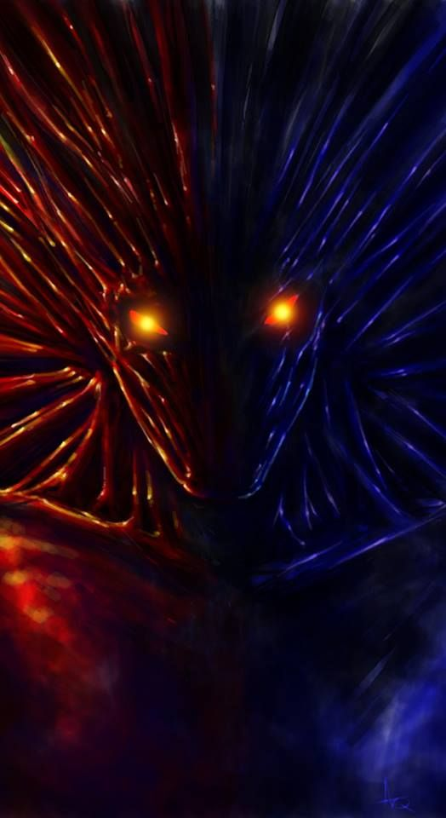

***The Shade King, Iromeouja***

**Current**

The Nara Clan founded Keikensho with the Hozuki clan, granting them a slightly higher status than the Aburame. They are led by the Shadow Priest, a Nara who leads them both in battle and prayer. Their current goals aren’t exactly public information but it is assumed that they are attempting to grow Keikensho for their own benefit. The Shadow Priest is known to go to a building called the Blackbox, a temple made of a special stone that absorbs and distorts any light, making the room completely black. This is where they commune with Iromeouja for guidance and knowledge of the world. They are known to partake in the lifestyle of shinobi, using their powers for battle.

Description

Nara are known to wear sheik clothing that is usually black or another dark tone of color as well as having ear and facial piercings. They have a constant black ring around their eyes that is a true marking of their heritage. They have extremely dark eyes rather than brown and a dark hue of hair.

Nara are very dedicated to Iromeouja, seeing him as a god for all the power and insight he has blessed them with. Due to their ability to talk to shades they are often regarded as extremely intelligent.

Player Guide

*Nara are extremely knowledgeable, even if they do not know how to counteract certain abilities, they usually know of them. This is due to the Shades that accompany them revealing secrets of the world to them. They have no knowledge of something that is newly created or lost in time, as the Shades have never witnessed it before.*

-Nara have the ability to speak to their Shades without actually speaking in the physical realm, allowing them to commune with them in security.

-Nara much like all other members of Keikensho do not enjoy simply killing, and would much rather leave one to fight another day or capture them for a more beneficial use.

-Nara like to wear fish-net, torn sleeves, and go for a more “Punk” style of outfit, as well as varying piercings and body modifications.

-Nara still practice the Monk style of living, and do not wish for violence unless it is necessary. Until provoked they are usually pacifist and often attempt to make ends meet without conflict.

-Nara’s education isn’t quite needed, as the Shades bless them with vast knowledge at birth. As well as advanced education on basic subjects like Math, Science, and English, the Nara have a vast knowledge of history and on all happening in the world. They are able to use all information provided on Lore and History.

-The Nara have a most plant based diet, but are known to partake in meat on rare occasions.